**CRF 112985_Digital Marketing NCA Report Automation**

1. Dotnet Login

2. CRF status report downloading

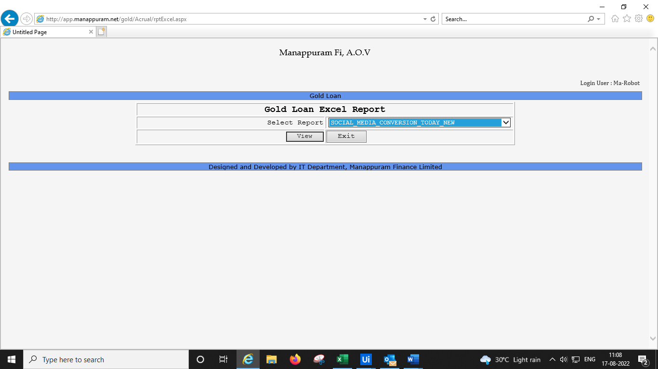

3. Report Formatting

4.Mail

